- fAB test
- Linear regression – Polynomial Regression
- Logistics Regression with usage of softmax functions
- Classification –Gradient Boosting
- RFM normal code and with classification implementation
- ARIMA and Prophet
- Neural Networks
- CNN vs RNN
- How to use grid search for optimisations
- Formula for duration of AB tests

Stochastic models are those models where there is a randomness associated with the both input and output and the models shows a probability distribution of different scenarios
Markov Channel Attribution Model –
- Stochastic Channel Attribution model
- Consists of different states and shows the probability of moving to different state from the give state. The probability of the current state is completely independent of the earlier states
- Shows the actual attribution of each and every state in the conversion process using conditional probability
- P(A/B) = P(A) intersection P(B)/ P(B)
- It is based on conditional probability and removal effect and calculates how does the success rate is impacted if a specific state is removed from the customer flow
- Simulation of Channel removal - For e.g. to calculate the contribution of a channel X in the conversion process, we look at the overall conversion if channel X is removed from all the cycles. If X is removed, the path is either removed if no similar path exists or paths performance is imitated to an existing similar path where channel X doesn’t exit.
- Removal Effect =1 - P (Conversion/ X state is not available) / P (Conversion)
- The python libraries used are – ChannelAttribution
- We are receive a chart which shows us the chances of other state from one state
- Higher is the removal effect, higher is the contribution of channel in conversion scenarios
Requirements
- A sequentially flow of the different channels used by a customer before buying a product and in how many situations it leads to user dropping off from the flow
- In addition to the attribution channels involved, we add start, convert and non-convert state and then calculate the sequences used by customer
- Code - https://medium.com/@akanksha.etc302/python-implementation-of-markov-chain-attribution-model-0924687e4037
Output: The Markov Channel attribution model helps us understand the actual attribution of each and every channel in the conversion process

Standardization Vs Normalisation
Normalisation corresponds to restricting values between 0-1 where Standardization has mean as 0 and standard deviation as 1
Variance = Σ f(x – x (i) )^2 / N
Standard Deviation = sqrt ( Σ f(x – x)^2 / N )

Kurtosis = Helps us understand the degree of skewness and is calculate with u(4)/ u(2)^2 where u(4) is the fourth central moment and u(2) is the second central moment
U(4) = Σ f(x – x(i)) ^ 4 / N
U(2) = variance
High Kurtosis means the data is not skewed and there are heavy outliers which indicates that there are outliers while low kurtosis means that data is skewed and thus low outliers
Probability:
P(A/B) = P(A ∩ B) / P (B)
P (A ∩ B) = P (A) * P (B) is A and B are independent events

Bayes Theorem:
P (A1/B) = P(A1) * P (B / A1) / ( P(A1) * P (B / A1) + P(A2) * P (B / A2))

Native multinomial bayes scenarios are bases on conditional probabilities. It is also known as naïve because all label irrespective of the order is same. Bayes theorem have high bias errors.

Binomial Distribution: For Binomial distribution, p and q are probabilities of success and failure and it shows us the probability of x successes in n outcomes
P(X) = nCx * p^x * q^(n-x)
Mean = E(x) = np
Variance = E(x^2) – E(x)^2 = npq

Poisson Distribution: For Poisson distribution, we determine the probability of x success in a fixed interval of time and space when the average number of successes are λ
P(x) = e power( - λ) + λ power(x) / x!

The Poisson distribution is a discrete distribution in which we know for a fixed interval of time the average number of occurrences is λ and we try to predict the probability of have x occurrences.

Exponential distribution: The exponential is also related to Poisson but it focuses on the time for the first event to occur or between any consecutive events.
We find the probability if no event occurs within a fixed time interval ‘t’ with x = 0
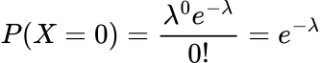
If we have to wait for ‘T’ time periods, the probability would be P(T>t) = e * power (- λ*t) since all the events are mutually exclusive
Thus, for an event to occur after T time periods, P (T <= t) = 1 - e * power (- λ*t)
Since it is from P(T <= t), this is also This is also the definition of the Cumulative Distribution Function (CDF).
The derivative of the CDF is the Probability Density Function (PDF):
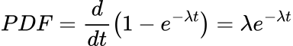
Example:
We have an average rate of 5 claims per hour, which is equal to an average waiting time of 12 minutes between claims. what is the probability that the first claim occurs within the first hour?
To calculate this we simply integrate the PDF between the bounds of 0 and 1:
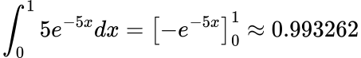
URL: https://towardsdatascience.com/exponential-distribution-simply-explained-349d05b1bdb8/

Gamma Distribution: Gamma distribution also is similar to Poisson Distribution. Poisson distribution focuses on the count i.e. probability of having x count when the average number of counts for a fixed interval is lambda.
Gamma distribution focuses more on the time and answer questions like what is the average time you would need to wait for the nth event.
The problem with the Exponential Distribution is that it only infers the probability of the waiting time for the first event or between any consecutive events. However, the Gamma Distribution gives us the probability of the waiting time until the nth event.

For the Gamma Distribution T is the random variable. This means we need n-1 events to occur in time t:
Now we need to sum up the probabilities of having 0 to n-1 events occurring in the time period t using the Poisson Distribution’s Probability Mass Function (PMF):
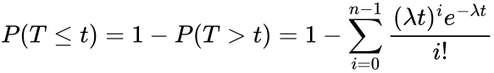
To extract the Probability Density Function (PDF) we just need to find the derivative of the CDF with respect to t as thats the random variable.
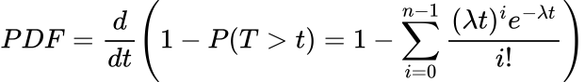 he final version of the PDF reads:
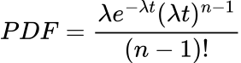
The reason the distribution is named the Gamma Distribution is because it contains the Gamma Function:

Bernouli Distribution: In Bernouli distribution there is only one trial
Mean = Expected value = p * 1 + (1-p)* 0 = p
Variance = p (1 – p)

Geometric Distribution:
URL: https://towardsdatascience.com/geometric-distribution-simply-explained-9177c816794f/
Geometric distribution shows us the probability of success after n failures
As the Geometric distribution is heavily related to the Bernoulli and Binomial distributions, its probability mass function (PMF) takes on a similar form:
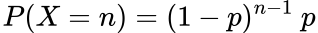

Beta Distribution:
Useful link: https://www.youtube.com/watch?v=1k8lF3BriXM
Article - https://towardsdatascience.com/beta-distribution-simply-explained-839b3acde6e9/
Beta distribution is the distribution of probabilities. When we calculate the probability for event, there is always error associated with it as it is not correct. Beta distribution models the probabilities. Thus, Beta distribution would always be between 0 and 1.
For e.g. at a specific state, there are ‘a’ successes and ‘b’ failures.
Then the mean of expected probability would P and the variance would be
(P power(a) * (a+b)C(a)) * ( (1-P) power (b) * (b) c (b))/N
If we rewrite it, The probability density of function (PDF) of the Beta distribution is:
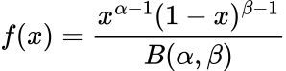
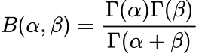
Some observations:
- When a and b are less, we have less samples to work with and thus variance is high
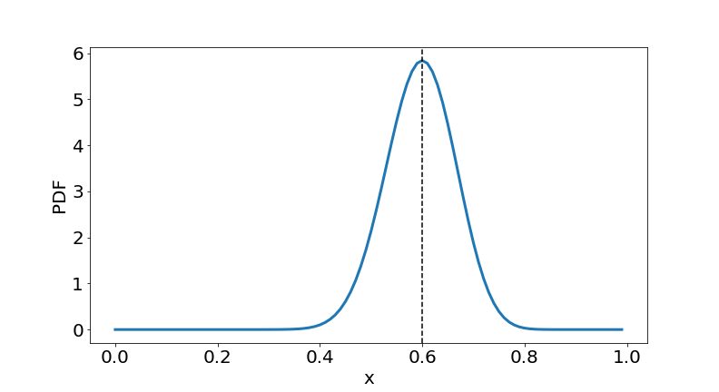
- When a and b are high, we have higher samples to work with and thus the variance is lesser that what it used to be.
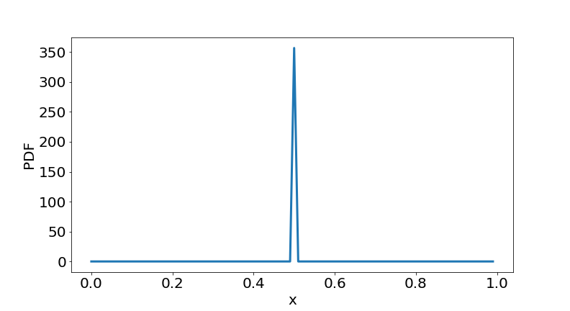

Chi Square test – Chi square test is primarily used for categorical variables and tests
- The relationships between two categorical variables if they correlated or not
  - This is used to see if we should remove some of the categorical features from the model or not
  - The chi square test is done between target variable and the other features
  - If there is a high association, the p value will be lower and if there is a low association P value will be higher
  - If the P value is high, we should remove the feature
- Goodness of fit to follow if the categorical variables distribution follows a normal distribution or if the data is uniformly spread between different features. If the data is uniformly distributed, the number of values by feature should be same and is expected value. If it differs a lot from observed, the data is not uniformly distributed
- Chi square test = Σ (Observed – Expected) ^ 2 / Expected variables
- For determining the relationship between categorical variables, we calculate expected value by ( row total * column total / overall sample size)
- The number of degrees of freedom is calculated with (number of rows – 1) * (number of columns – 1)

Normal Distribution: For normal distribution, mean is 1 and standard deviation is 0.
F(x) = (1 / (σ * sqrt ( 2 * π)) * e power (-1/2 * (x – u/ σ) *2))
- 68% of data is within 1 standard deviations
- 95% of data is within 2 standard deviations
- 99.7% of data is within 2 standard deviations
Z score = (X – u) / σ
- If your alternative hypothesis involves words like "greater than," "less than," "increase," or "decrease," you'll likely use a one-tailed test.
- If your alternative hypothesis involves words like "different," "change," or "not equal," you'll likely use a two-tailed test.

Sampling methods:
- Stratified Sampling – The population is divided in stratas which are homogenous inside and heterogenous outside and we extract some samples for each stratas so that their ratio resembles the population
- Cluster Sampling – The population is divided in clusters which are heterogenous inside and homogenous out
- Random Samples
Non-Probabilistic Methods:
- Convenient Sampling – The users are selected basis convenience
- Judgement Sampling – The samples are selected basis users judgement
- Snowball Sampling – you ask the already selected samples for others

Central Limit Theorem – If we plot the mean of the samples of a population, then the distribution so formed will be a normal distribution with mean as mean of the entire population and standard deviation as σ / sqrt(N) where σ is the standard deviation of the population and N is the size of sample

Confidence Interval – The possib
ility of obtaining a value as far as the one we have
Margin of error - σ / sqrt(N) is known as margin of error
Z score = (x – u)/ (σ / sqrt(N)) is critical value
Probability for the Z score basis one to two tail test is 0.05 or 0.025
If sample size is greater than 30, we considered Z score and if the sample size is less than 30, we consider F score with degree of freedom N-1

Hypothesis Testing –
Null Hypothesis (H0) – There is no statistical difference, Alternate Hypothesis – There is a statistical difference
Type 1 error (False Positive) – reject a null hypothesis when it was True.
Type 2 error (False Negative) – fail to reject a null hypothesis when it was not True
For Medical Testing, Type 1 error are more dangerous than type 1 error
For 95% confidence interval, if the Z score > 1.96, we can reject the Null hypothesis
Power is the probability of correctly rejecting a null hypothesis when it is false. It is 1-Beta where Beta is type 2 error

Test of difference of Means of different populations
Sample 1 – X1 is the mean of sample and U1 is the mean of population
Sample 2 – X2 is the mean of sample and U2 is the mean of population
Z – (X1 – U1) – (X2 – U2) / (sqrt ( S1^2 / N1 + S2 ^ 2 / N))

How it is used in AB test:
Conversion Rate of Control = C1
Conversion Rate of Variant = C2
SD of Control = sqrt (P1 * (1 - P1) / N1)
SD of Variant = sqrt (P2 * (1 – P2) / N2)
Z Score = C1 – C2 / sqrt (SD1 ^ 2 + SD2 ^ 2)

A/B Test Duration Calculator Guide
$$\text{Number of Days}=\frac{\text{Required Total Sample Size}}{\text{Samples per Day}}$$
Step 1: Calculate Required Sample Size Per Variation
For conversion rate testing (binomial metrics), the sample size per variation is calculated using:
$$n=\frac{\left(Z_{α/2}+Z_{β})^{2}×(p_{1}(1-p_{1})+p_{2}(1-p_{2})\right)}{\left(p_{2} − p_{1})^{2}\right.}$$
$$\text{Required Total Sample Size}=n×\text{Number of Variations}$$
1. Expected Improvement (MDE)
- The minimum detectable effect you want to detect
- Expressed as a percentage or decimal
- Example: 10% improvement means MDE = 0.10
- Smaller MDE requires larger sample sizes
2. Statistical Power (1-β)
- Probability of detecting an effect when it truly exists
- Typical values: 80% or 90%
- Higher power = larger sample size needed
- Protects against false negatives (Type II errors)
3. Significance Level (α)
- Probability of false positive (Type I error)
- Typical value: 5% (95% confidence)
- Lower α = larger sample size needed
- More stringent = fewer false alarms
4. Baseline Conversion Rate (p₁)
- Current conversion rate of control group
- Must be known from historical data
- Affects required sample size
- Rates closer to 50% require larger samples
5. Samples per Day
- Average daily traffic/visitors
- Should be consistent and reliable
- Consider weekly patterns
- Account for traffic allocation to test

T test – The T tests are usually done when the sample size of a sample is less than 30. For the T test the same size is N-1
T test of difference of means is
(x1-u1) – (x2 – u2) / S * sqrt (1/N1 + 1/N2)
S = 1 / (N1 + N2 – 2) * (N1 * (SD1 ^ 2) + N2 * (SD2 ^ 2))

Analysis of Variance – It tests if one of the samples is substantially different from others
The Total variation = Variation between the groups + Variant in the elements of the groups
F test = (Variation Between the groups / ( K – 1)) / (Variation within groups / (N – K))
Here K is the number of groups and N refers to the number of elements

Correlation – Conrrelation is used to find the degree of association between two independent numerics
- Simple Correlation – It tests the degree of relationship between variables
- Partial Correlation – It test the relations after removing the effect of other variables
- Multiple Correlation
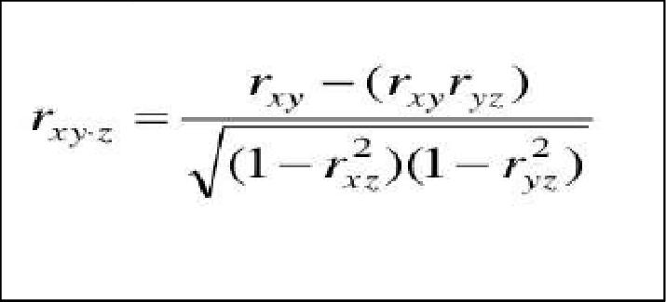

Pearson Correlation – Just a product of Z score of the variables involved
R = Σ (Zx * Zy / N)
Zx = (X1 – U1 / SD1)
Zy = (X2 – U2 / SD2)

Partial Correlation –
R12.3 = R12 – R13 * R23 / (sqrt (1 – R13 ^ 2) * (1 – R23 ^ 2))

Cross Validation – Cross validation means how well the model will generalise to the new data. We divide the data as test and trains and uses test for the same

K Fold cross validation – The data is distributed in K folds with K-1 used to train data and the final for test data. The final result is the average of all the performance scores such as recall etc
Unlike normal test train split, where the data just below to test or train and can lead to high errors, all the data is used to train the model
K Fold is used to understand how well the model evaluated the output metrics such as precision, accuracy recall etc.
K Fold works with Grid Search. For Grid search, you provide all the possible combination of hyper parameters that you want to train and then K fold finds the robust scores by averaging the output of K trained models.

Bias Variance Trade-off –
Bias error is because of approximation which occurs when the model is not complicated and it doesn’t adjust completely to the input data. Thus, the model has high bias error and fails to capture the patterns in the data which are causes underfit.
Variance – It is used to understand the performance of a model on the train data. When the model is over fits, it doesn’t fit with test data and causes high variance. There is a trade-off between bias and variance.

Gradient Descent / Stochastic Gradient descent
For GD and SGD, we do a partial differentiation of the loss function with respect to the coefficients. For GD, we take in the entire data set but for SGD, we use one random value or a batch of random values. As a result, the processing speed of SGD is higher than gradient descent
X(n + 1) = X(n) – PF for loss function F(X(n)) * learning rate
Y(n + 1) = Y(n) – PF for loss function F(Y(n)) * learning rate
For GD, the loss function function consists of the entire data set while for SGD, the loss function function consists of one random entry or a batch of random entries

Gradient Descent:
Regression equation Y = aX + b
Loss function F(x) = Σ (y1 – Y(x1)) ^2 = Σ (y1 – aX – b) ^ 2
PF(a) = ∂(F)/ ∂(a)
PF(b) = ∂(F)/ ∂(a)
Learning rate = 0.01
We start with some random value of a and b
a(n + 1) = a(n) – PF(a) for all the x and y values in data set * learning rate
b(n + 1) = b(n) – PF(b) for all the x and y values in data set * learning rate
This continues for 1000 repetitions so that the elements are similar

Coefficient of determination:
The coefficient of determination is calculated as a ratio of Explained variation / Total variation
Coefficient of determination = r2 = 1 – Σ (y(i) – y(predicted))/ (y(i) – y(mean)

Assumptions for linear regressions:
- There is a linear relationship between dependent and independent variables
- The residuals are not correlated to each other. Durbin Watson test is used to test this
- The residuals are normally distributed. Shapiro test is done to test this.
- The features are not correlated to each other
- The output is not related to its previous terms
- Homoscedasticity – For any predicted value, the spread of variance is uniformly and thus if we calculate the distribution of error, it would always be zero and variance would always be the same.
The output of linear regression –
- Coefficient of determination = To understand how much of variation is explained by the line
- Adjusted R – To understand if there is a correlation between the variables
The linearity in linear regression is between output and weights of features. That’s why polynomial regression is also a type of linear regression where features are of higher order.
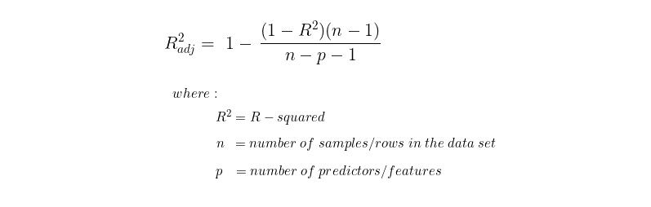
- Weights – The coefficient weights both standardised and unstandardised
  - Unstandardised weights are the ones that are to be used for the predictions.
  - Standardised weights tell us relative role of the features used for the analysis.
- ANOVA test – To understand the good of fit of the regression lines. ANOVA in regression is a division of average variation expressed by the model and average unexplained variation
.12
Anova test tells us whether there is a significant association between independent and dependent variables.
Null Hypothesis: All regression coefficients (excluding the intercept) are zero. None of the independent variables have a linear relationship with the dependent variable.
Alternative Hypothesis: At least one of the regression coefficients is not zero.5 The model is statistically significant and the independent variables collectively explain a significant amount of the variation in the dependent variable.
The general formula for the F-statistic in a multiple regression model that tests the null hypothesis that all slope coefficients are zero is
$$F=\frac{\text{MSM}}{\text{MSE}}=\frac{\text{SSM}/{\text{df}}_{\text{Model}}}{\text{SSE}/{\text{df}}_{\text{Error}}}$$
The Coefficient of Determination is defined as
$$R^{2}=\frac{\text{SSM}}{\text{SST}}=1-\frac{\text{SSE}}{\text{SST}}$$
Term | Also Known As | Formula
SSM | SSR (Regression) or ESS (Explained) | $\sum (\hat{y} - \bar{y})^2$
SSE | RSS (Residual) | $\sum (y - \hat{y})^2$
SST | TSS (Total) | $\sum (y - \bar{y})^2$

By substituting and rearranging, you can derive the following relationship, which proves they are linked, but not equal
$$F=\frac{R^{2}/k}{\left(1-R^{2})/(n-k-1\right)}$$
Where $k$ is the Number of Predictors (the degrees of freedom for the model, ${\text{df}}_{\text{Model}}$)
$n$ is the Total Number of Observations.
$\left(n − k − 1\right)$ is the Degrees of Freedom for the Error (${\text{df}}_{\text{Error}}$).
Interpretation: A high $R^{2}$ means the model explains a large proportion of the variance.
A high F-statistic means the model is significantly better than a simple mean-only model (i.e., you reject the null hypothesis)

- P value of the weights – It is by feature and tells us whether the feature is relevant or not for the analysis

SVMs:
Normalization is highly recommended.
Correlation can be a concern, but SVMs are relatively robust.
Decision Trees:
Normalization is generally not required.
Correlation has minimal impact.

K Means Cluster –
K Means Cluster splits the data in K clusters. It starts with choosing K entries and then calculate the Euclidian distance for every point. Every instance, a point is added to the cluster, the mean is recalcined for the cluster. This continues until the means doesn’t improve drastically after every iteration or it crosses the threshold.
K Means cluster algorithm has the following hyper tuning parameters:
- The number of clusters
- The max number of iterations for which the instances are to be added
- Initialisation method – it is very critical that the entries chosen at the start are correct. There are some ways in which you can choose those entries
  - Random – Then entries are chosen at random
  - K Means ++ - It is the default one and the one that is used the most. Here the first entry is random and the other subsequent entries are selected in such a way that the entry is at the maximum distance from already selected entries
- Number of initialisations – The number of instances for which the entire cycle is to be repeated such that we choose the one with minimum variance
Calculation of Variance – For every cluster, you look at the average and calculate the variance of every value in the cluster. The variances so calculated are summed up for every cluster to calculate the total inertia for K means
Number of clusters:
The number of clusters is selected basis a curve between inertia and the number of clusters. Inertia is sum of variance at the cluster
K Means cluster are sensitive to outliers and since it uses Euclidian distance, the values should be normalised before the usage

Support Vector Machine:
Support Vector Machine or SVM is a line or in many dimensions a hyperplane which classify the data with maximum margins. They are binary classifiers. Support Vector are the data points which are the closest to the hyperplane or the decision boundary and set its direction. The decision boundary is created in such a way that the decision between the support vectors and the line is the highest
Hard Margin – Enforces the decision boundary is precise and could result in over fit since the outliers can interfere the boundary
Soft Margin – Allows some misclassification so that it doesn’t overfit and there is less
Cost function = ½ * |w|^2 + λ * Penalty
Here Penalty refers to the number of misclassifications. Penalty is the square of distance between misclassification and boundary. It is also referred as hinge loss
|w|^2 is square of weights of coefficients of support vector. We minimise weights because minimisation of weights increase margin which is different between support vector and hyperplane.
Proof – If hyperplane is ax + b = 0, then support vector is ax + c = 0 since support vector and hyper plane are parallel to each other.
Distance = (c – b) / |a|
Thus if we minimize a, the margin increases

Support Vector Transformations
Support vectors are inherently linear classifiers and thus do not work well with non linear data.
For Non-Linear data, some additional features are introduced to the existing data to elevate the data in a higher dimensional space where it can be separated with decision boundary
The additional features are obtained using a transformation function and this process is called Kernel. Some of the Kernels used are Linear Kernel, Polynomial Kernel, Radial Basis and sigmoid functions.
$$K(x,x^{'})=exp(-γ||x-x^{'}||^{2})$$
The transformation for SVM function can be very complex and thus rather than doing the transformation for every data entry. We do a dot product of data entries without calculating the transformation. This is known a Kernel trick
Standardisation and Normalisation - SVM requires both standardisation and encoding of category-based variables.
Disadvantages –
- Difficult to compute for large data
- Tune parameters are difficult to find – Kernal functions, λ and gamma the coefficient in radiant or polynomial kernels. The default values are [0.001, 0.01, 0.1, 1, 10, 100, 1000]
- Relatively difficult to understand because of the hyperplane
- Sensitive to noise
Accuracy of SVM – Confusion matrix can be used to determine the efficiency of SVM
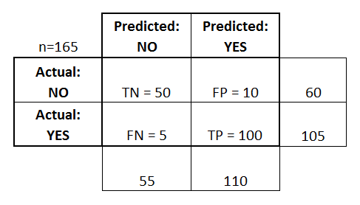
Here FN are type 2 errors and FP are type 1 errors
Precision – Correct Positive cases out of all the cases predicted as positive. Precision = TP / (TP + FP)
Recall or Sensitivity or True Positive Rate– Correct positive cases out of actual positive cases. Recall = TP / (TP + FN)
F1 Score = Precision * Recall
Specificity – Correct negative cases out of all the negative cases. Specificity = TN / (TN + FP)
False Positive Rate = FP / (TN + FP)
Accuracy can be mislead in imbalanced data sets. Thus we should see F1 score

To identify a disease, it is very important that we identify all the actual cases infected with a disease and thus TP and FN become very important. Thus, for such cases, recall is the preferred metric
To understand the right threshold for a model, we use ROC curve which consists of True Positive Rate (Recall) and False Positive Rate (1 – Specificity). The Area under ROC curve is know as AUC or the area under the curve. ROC AUC curve assists us to identify that which threshold is the best for making a decision.

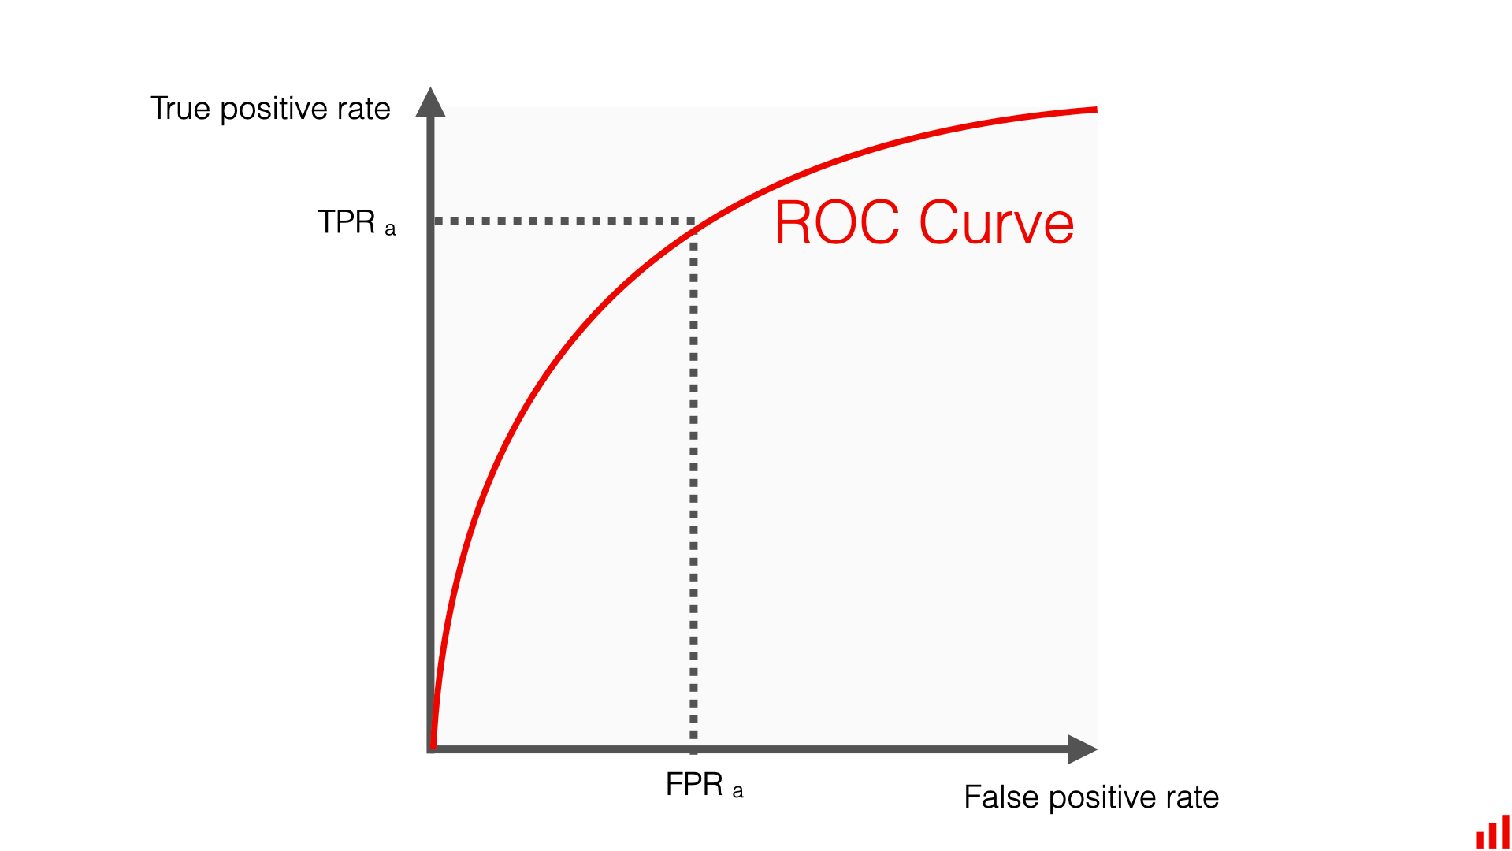
How ROC and AUC curves are used for classification:
AUC shows area under curve for ROC. AUC is the first step that helps us understand which model is better. Higher the AUC better the model.
Learning Curve tells you if you have enough data, the AUC tells you how good your model is at "sorting" or "ranking" your classes (e.g., distinguishing Fraud from Not Fraud)
Once you find the best model with AUC, the nest step is to identify, what should be the right cutoff for classification of a value as 1 or 0. The default is 0.5.
ROC sequentially changes cutoff from 0 - 1 and show TPR and FPR for very cut. From this your get to understand which cutoff is the right for you. You then use it to predict the probabilities.
# Instead of: y_pred = model.predict(x_test)
# Use your custom threshold: custom_threshold = 0.35
# The one you picked from the ROC analysis
y_probs = model.predict_proba(x_test)[:, 1] y_pred_custom = (y_probs >= custom_threshold).astype(int)

K Fold Cross validation –
For K Fold cross validation, the data is divided in K folds. The K-1 folds act as train data and one fold act as test data. This process is done K instances so that every fold act as a test data.
The average of all the folds is done to calculate the final weights. This reduces overfit and also increases a robust estimate
While k models are indeed created during the process, the goal of K-Fold Cross-Validation (CV) is to evaluate the performance of your modeling approach, not to produce the final set of coefficients.
To find the "true" coefficients, you follow a standard two-step workflow. You don't get the final coefficients from the cross-validation process itself; rather, you use cross-validation to prove your approach works, and then you perform a final fit.

Learning Curves:
Learning curves are used to understand how many training data points are needed to better models performance.
How is learning curve created:
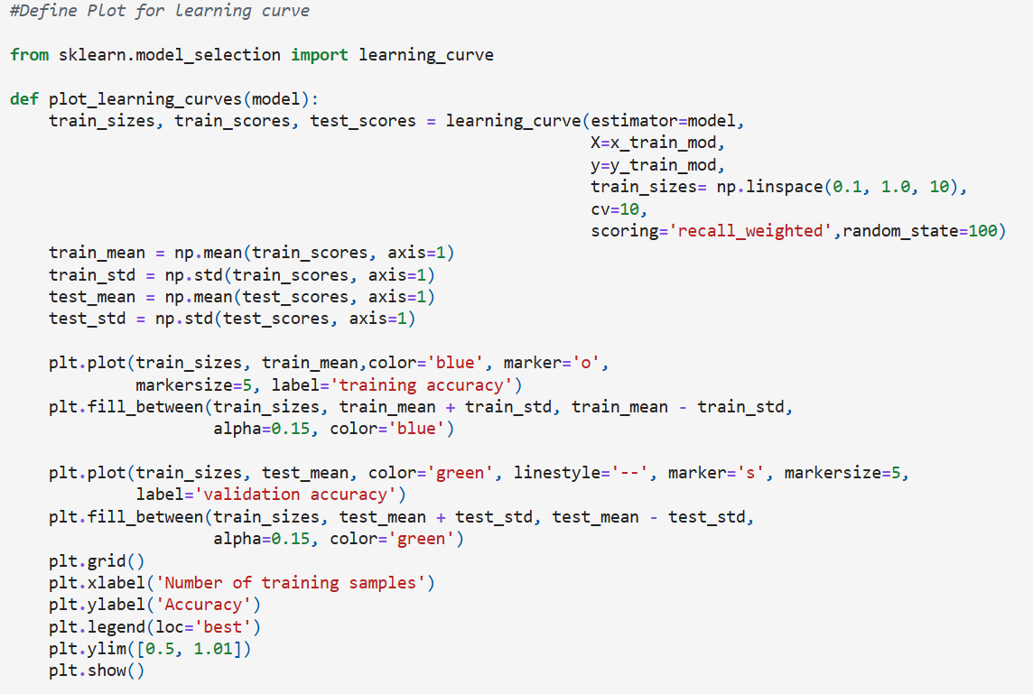
  - The data is first broken in test and train using test train data split in scikit learn
  - Vanilla models (with default parameters) are applied using learning curve function
  - Learning curve only works on train data set
    - It takes vanilla model
    - Sequentially extract random data point using trainsize argument from 10% to 100%
    - From the data extracted, using CV arguments, the extracted data is in turn divided in N folds where N-1 fold are used for training and 1-fold is used for testing the data
    - Cross validation also created N models and then uses the mean for better data
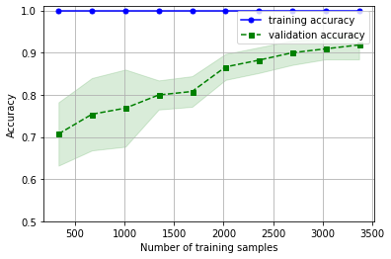
  - The plot further is user to understand how training and validation accuracy varies and the minimum number of samples required to remove chances of overfit

Decision Trees:
Decision trees is a multi-class classifier which recursively divide the data basis the informative feature. It starts with a root and can have many branches. Each branch represents a feature and the label in that feature which reduces the impurity
- Start with the entire dataset at the root node.
- Select the best feature to split the data (based on measures like Gini impurity).
- Create child nodes for each possible value of the selected feature.
- Repeat steps 2–3 for each child node until a stopping criterion is met (e.g., maximum depth reached, minimum samples per leaf, or pure leaf nodes).
- Assign the majority class to each leaf node.
For numeric value, the data is sorted and the impurity is calculated with each entry to understand which one has the highest coefficient
For e.g.
Feature | Blue | Green | Blue | Blue | Blue | Green | Green | Green | Green
Y | Yes | Yes | Yes | No | No | No | No | No | No

For both blue and green label, we would determine the GINI coefficient. The gini coefficient for Blu label is calculated as G = 1 – P1^2 – P2^2. Here P1 and P2 shows the purity of Blue for respective classes
Feature | 1 | 0 | 1 | 1 | 1 | 0 | 0 | 0 | 0
Y | Yes | Yes | Yes | No | No | No | No | No | No

Gini Coefficient for first class = 1 – (2/3)^2 – (1/3)^2
Gini Coefficient for Second class = 1 – (2/6)^2 – (4/6)^2
Total Gini Coefficient = G1 * 3/9 + G2 * 6/9
Gini coefficient should be less as it is inverse to purity of the data
Standardisation and Encode – Decision Trees don’t require standardisation and encode of categorical features
Benefits of Decision Trees – Easier to understand and versatile, can capture non linear relationships, and can handle outliers
Why should we not use the same – Overfit, can take approximations for thresholds, and high to process for big data sets
How to Hypertune decision trees –
- Max Depth – The maximum depth of the tree
- Minimum sample split – The minimum number of samples required to perform a split. The default is 2
- Minimum sample leaf – The minimum number of samples in a leaf. The Default is 1
- Criteria – Gini coefficient or entropy
- Max features – The maximum number of features to look for when performing the split

Other Criteria’s:
Entropy=−∑p(i) * log2​(p(i)​)
You calculate the entropy of the entire data set which is 0.4 * log(0.4) + 0.6 * log(0.6)
And for different classes - 2/3 * log (2/3) + 1/3 * log (1/3)
Gain is calculated from the difference.
Higher the gain better is the feature for this scenario

Entropy is also inverse and should be reduced for the data sets

Decision Trees outputs: The output of decision trees is typically a class label. When a new data entry enters a leaf node, the tree predicts the class that is the most prevalent.
In order to understand which features are the most useful for decision trees, we Impurity-Based Feature Importance:
How it's Calculated:
Impurity Metric: Decision trees use impurity metrics like:
- Gini Impurity (for classification): Measures the probability of incorrectly classifying a randomly chosen element in the dataset if it were randomly labeled according to the distribution of labels in the subset. A Gini impurity of 0 means a perfectly pure node (all samples belong to the same class).
- Entropy (for classification): Measures the level of disorder or uncertainty in a node. A lower entropy indicates a more homogeneous node. Information Gain is the reduction in entropy after a split.
- Mean Squared Error (MSE) / Variance Reduction (for regression): Measures the variance of the target variable within a node. A split that significantly reduces this variance is preferred.
- Weighted Impurity Reduction: For each split in the tree, the reduction in impurity is calculated. This reduction is then weighted by the proportion of samples that pass through that node.

Example (Gini Importance): If a feature is used to split a node that contains 100 samples, and this split reduces Gini impurity by 0.2, then this feature gains 100
times0.2=20 in importance for that split.
Aggregation: The importance of a feature is the sum of these weighted impurity reductions across all nodes where that feature is used for splitting in the entire tree.
Normalization: The final importance scores are typically normalized so that they sum up to 1, making them easier to interpret as relative contributions.

Decision tree for regression –
URL - https://towardsdatascience.com/decision-tree-regressor-explained-a-visual-guide-with-code-examples-fbd2836c3bef/
Decision trees can also be used for regression. For every branch we select the value such that sum of mean of variance in both the splits is minimised.
For categorical data, if we split the data in different buckets, we would calculate the mean of each bucket and calculate the variance. The variance is added with ratio to understand the effective RMSE.
We continue this set and the final output for each leaf is the average of all values left in the data.

Random Forests –
Random forests are ensemble methods i.e. they use a combination of model to determine the output. For classification they take the majority vote and for regression it averages the values
Random forest only works on decision trees
Bagging – In bagging, the samples for different models are generated using techniques like bootstrapping and the samples generated are independent of each other.
Bootstrapping – For bootstraps, we select random entries from the data with replacement until the size of the sample becomes equal to the size of the original datasets. As a result, the sample would also have some duplicates
Further, each decision tree, at every level will have only evaluate a random number of features to find the split. This number of features that are to be used is one of the hyper tune parameters for decision trees
Hyper tuning parameters in Random forests:
- Number of decision trees – The value is between 100 to 1000
- Max features in each decision tree – We need to pass in a sqrt or log functions for this
- Max depth of every tree
- Minimum samples split – The minimum samples to be split further
- Min samples leaf – The minimum number of samples in a leaf
- Bootstrap – Whether bootstrapping is to be used or not
- Criteria – The criteria for split – Gini or Entropy

Boosting -
Random Forest also consists of sequence of weighted decision trees where each decision trees learns from the errors of its predecessor decision trees. Ad boost is generally a binary classifier and each entry has the same weight (1/N) at the start. The Gini coefficient is calculated with weights to determine the feature that is to be used for every decision trees.
After the output of one decision trees, the weights are readjusted to have better focus on the values which were wrongly classified earlier. The weights are readjusted using the value
alpha = n * log (1 – error rate / error rate)
Here n refers to the learning rate and error rate is the sum of the weights which were incorrect classified. The new weights are calculated as
W(i) = W(i-1) if there was correct classification, W(i-1) * alpha if there was incorrect classification
The resultant weights are normalised the next best feature is used for the classifications.
Hyper tuning parameters in Adaboost:
- The number of estimators or the number of trees to be used
- The learning rate in calculation of alpha [0.001, 0.01, 0.1,1]
- base_estimator: You can also use logistics regression in addition to decision trees
- base_estimator__max_depth: The depth of each decision tree. The default is 1
Benefits of Adaboost:
- Adaptive learning
- Resist overfitting as every estimators focus the errors of others
Issues with Adaboost:
- Sensitive to noise

XG boost is a multi class classifier and uses SoftMax function to calculate N different classification scores.

Ridge Regression
Ridge regression or L2 regularisation is used to reduce data overfit by reducing coefficient’s sensitivity to change in data.
Ridge Regression = sum of Residuals + λ * square of coefficients
The labda is penalty term and if it is higher, we would need to reduce square of coefficients which would result in decrease of sensitivity. This would be result in low bias and thus reduce variance error due to overfit.
Ridge regression can reduce the size of the coefficients but do not remove the same
Lasso Regression or L1 is sum of residuals and λ * sum of coefficients. It can remove the coefficients to zero and thus help us find the useful columns.
Cross validation is used to find out the λ for ridge and lasso
We pass in a number of lambda values and choose the ideal one with grid search.
Lambda = [0.001, 0.01, 0.1, 1, 10, 100, 1000]
Ridge shrinks the coefficients which are correlated to each other but doesn’t make them zero, lasso shrinks them to zero and choose one of the features for correlation analysis. You favour lasso for automatic features selection analysis.
Elastic net is a combo of both of those in analysis.

Principal Component Analysis –
Principal Component Analysis turns a higher dimension data set in lower dimension data set but creating new features which are a linear combination of existing features
- The new features are equal to the number of original features
- These new features try to maximise the variance and are sorted basis the amount of variance they can explain. Thus, you can look at the Scree plot (feature number vs the total percentage of variation) to identify how many new features should be considered for building the model
- The new features direction is called eigen value while their magnitude is called eigen vector
- The new features are orthogonal to each other and thus reduce the errors due to partial correlations
Important - The data must be standardised before usage of PCA
Resources - https://www.youtube.com/watch?v=FgakZw6K1QQ
Code:
from sklearn.decomposition import PCA
from sklearn.preprocessing import StandardScaler
# Standardize the data (important for PCA)
scaler = StandardScaler ()
scaled_data = scaler.fit_transform(data)
# Create a PCA object pca = PCA(n_components=2) #Here N is the number of new features, if you pass a decimal value, PCA would extract those many features which shows that much variations
# Specify the number of components
# Fit the PCA model to the scaled data and transform it
transformed_data = pca.fit_transform(scaled_data)
# Access the principal components principal_components = pca.components_
# Access the explained variance ratio explained_variance_ratio = pca.explained_variance_ratio_

Linear Discriminant Analysis (LDA)
Linear discriminant analysis also turns higher dimensional data into lower dimensions by maximising the difference between means and minimising the scatter within the groups.

Logistics Regression:
It is a classification algorithm that predicts the probability for a linear combination of variables. If the probability is above a specific threshold, the value is 1 else the value is 0.
The logistics regression using sigmoid function to calculate the probability.
P = 1 / (1 + e ^ (-Z))
Where Z(x) = c + a1 * x1 + a2 * X2 + a3 * x3 + a4 * x4 …..
The cost function is as follow
C(x) = - Y * log (P) - (1 – Y) * log (1 – P)
Intuition about cost function:
- If y = 1 (the actual class is 1), the cost is -log(p). If p is close to 1 (correct prediction), the cost is close to 0. If p is close to 0 (incorrect prediction), the cost is large.
- If y = 0 (the actual class is 0), the cost is -log(1 - p). If p is close to 0 (correct prediction), the cost is close to 0. If p is close to 1 (incorrect prediction), the cost is large.
Regularisation in logistics regression:
New Cost functions with Ridge Regularisation = C(x) + λ * square of coefficients
New Cost functions with Lasso Regularisation = C(x) + λ * mod of coefficients
New Cost functions with Elastic net Regularisation = C(x) + λ * square of coefficients + λ * mod of coefficients
How to select the right threshold for Logistics Regression:
The right threshold is determined using ROC curve and understand the required thresholds for sensitivity and specificity basis business
Hyper tuning Parameters for Logistics Regression:
- The penalty term for regularisation
- The type of regularisation – Ridge, Lasso or Elastic Net
- The optimisation algorithm
  - Liblinear – Normal gradient descent
  - Lbfgs – A newton-based method used as default for the regressions
  - SAG – Stochastic average Gradient descent
  - SAGA – Improvised version for Stochastic Average Gradient Descent
  - Newton – cg
Which one to use - liblinear is best for smaller datasets, while lbfgs, sag, saga, and newton-cg are better for larger ones.
Logistics Regression for Multinomial Classification:
We use SoftMax function for such scenarios. If the feature to be calculated contains 4 classes, we create 4 different binary models where we consider one class as is and group the other classes.
Z1(X) = C1 + A11 * X1 + A12 * X2 + A13 * X3 + A14 * X4…….
Z2(X) = C2 + A21 * X1 + A22 * X2 + A23 * X3 + A24 * X4…….
Z3(X) = C3 + A31 * X1 + A32 * X2 + A33 * X3 + A34 * X4…….
Z4(X) = C4 + A41 * X1 + A42 * X2 + A43 * X3 + A44 * X4…….
SoftMax function is used to calculate the likelihood of each class as follow:
S1(X) = e^Z1(x) / Σ e ^ Z(x)

SMOTE (Synthetic Minority Oversampling Technique)
SMOTE is also used to balance the data sets. For a specific data element for which the new values are to be generated, it looks for K nearest neighbours. If then creates a lines basis this and choose random elements to create synthetics elements

ARIMA
ARIMA stands for Auto regressive integrated moving average function
- Auto Regressive, P coefficient – There is autocorrelation and the current value is reliant on previous values. Partial correlation function is used to determine the coefficient
- Time series Integrated, D coefficient – The mean of the data is not average. There is a Trend to it. The seasonality is removed the difference. The order of difference is determined by Augmented Dicky Fuller test
- Order of the Moving average, Q coefficient – It takes the error that have occurred before so that they can be minimised in the next outputs. Autocorrelation function is used to determine the order. Because an q process only depends on errors up to lag q the correlation between the series y and its own past values, y becomes exactly zero (theoretically) for all lags k greater than q in such scenario.
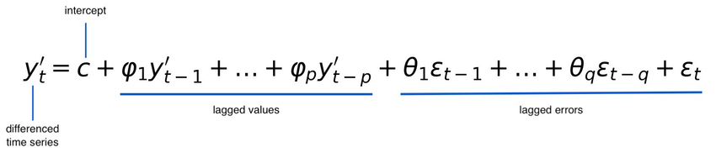
For P = 1, we take in account one previous value, D = 1, we need to difference the series once to make it stationary, Q = 4, the series relies on past 4 residuals or errors
Partial correlations determine the effect between two data elements when the other effects are removed, It helps in calculation for P value
The order of the moving average Q is determined on a stationary series. Autocorrelation helps identify the correlation between Stationary time series and its lagged errors
All the combination of the coefficients are tested with cross validation to determine which one has the best results. The results are calculated with RMSE Root mean square error.
ARIMA libraries
from statsmodels.tsa.stattools import adfuller
from statsmodels.graphics.tsaplots import plot_acf, plot_pacf
from statsmodels.tsa.arima.model import ARIMA

ARIMAX:
X stands for exogenous variables that are external and impact the series. The external series are combined in a data frame and are fed in model in exogenous arguments

SARIMAX:
The stationary difference is used to remove the TREND from the series. However, the normal ARIMA has no feature for seasonality that occurs after a specific period. You use ACF to understand the seasonality difference for the series.
- Seasonality coefficient: The seasonal period (e.g., 12 for monthly data, 4 for quarterly data, 7 for daily data with weekly seasonality).
- For removal of the general trend, we use Stationary differences
- Order of the seasonal Moving Average (SMA) component. The residuals or error of last terms
- Order of the seasonal Autoregressive (SAR) component.

Facebook Prophet:
Decomposable Additive Model: Prophet is an open-source library developed by Facebook's Core Data Science team. It's based on a generalized additive model (GAM) that decomposes a time series into three main components:
- Trend: A piecewise linear or logistic growth curve to model non-linear trends. The default trend is linear but if there is a threshold to the highest threshold, we use logistics trends.
- Seasonality: Modelled using Fourier series to capture various seasonal patterns (yearly, weekly, daily, etc.), and it can handle multiple seasonality’s easily. We use Fourier series as a fundamental concept of Fourier series is that any complex, periodic function (like seasonality in time series, which can have irregular shapes) can be approximated by a sum of sines and cosines with different frequencies and amplitudes.
- Holidays: Allows for explicit inclusion of known holidays and special events, as these can have significant and irregular impacts on the time series.
- Error term: Residual noise.
Strengths:
- Excellent at modelling multiple seasonality’s (e.g., daily, weekly, yearly) simultaneously
- Holiday Effects: It Explicitly allows for modelling the impact of holidays and custom events, which is crucial for many business time series.
Weakness:
- While it handles trend and seasonality well, it's not designed to capture complex, short-term autocorrelations in the same way SARIMA does.
- f the trend component is too flexible, it might overfit to noise. Tuning changepoint_prior_scale helps mitigate this.

RFM Models:
- Champions:
- Potential Champions – Who have the potential to be champions
- Loyalist – Who have stayed with us for a longer period
- At Risk Customer – Customers who haven’t purchased recently but used to a have a purchase history of frequent transactions
- Hibernating customers – Who haven’t purchased anything since a big duration
- Lapsed Customers – Customers who are no longer with us

SQL Window functions:
Aggregate functions (sum, count, max, avg, min)
- Total sum for a partition –
  - Sum (<<column name>>) over (partition by <<column name>>)
  - Here if we use order by it would be a rolling sum, hence for total sum we must not order by statements
- Rolling sum for the partitions
  - Sum (<<column name>>) over (partition by <<column name order by <<column name>>)
  - From first row to current row – sum (<<column name>>) over (partition by <<column name>> order by <<column name>> rows between unbounded proceding and current row)
  - From current row to end row – sum (<<column name>>) over (partition by <<column name>> order by <<column name>> rows between current row and unbounded following)
  - From 4 rows from the start – sum (<<column name>>) over (partition by <<column name>> order by <<column name>> rows between 4 preceding and current row)
- Lead functions – lead (<<column name>>, <<offset>>) over (partition by <<column name>> order by <<column name>>)
- Lag functions – lag (<<column name>>, <<offset>>) over (partition by <<column name>>, order by <<column name>>)
- Summation functions such as sum, first, avg, last are rolling functions by default which gives you a summation of value from first row to current row. Thus you have to forcefully add in Rows between unbounded preceding and unbounded following if you want to take the rows
- If you want to have all the rows, you need to do partition by characters and not by integers
- Window function for percentile – Percent_rank()
- Syntax: Percent_rank() over (partition by <<>> order by <<>>)

Clause | Action | Result
FROM | Selects all customer transaction records. | All rows.
GROUP BY | Groups all records by CustomerID. | One row per unique customer.
HAVING | Filters these customer groups to only include customers where SUM(Amount) > 1000. | Only customer groups with total sales over $1000.
SELECT | Specifies the final output columns: CustomerID and SUM(Amount). | The final table showing the ID and total sales for high-value customers.

Char Functions
- INSTR
  - Return the position of a character in string
  - Select instr(“hello hi”, “hi”)
- Substr – select substr (“hi hello”, 1, 3)
- Replace – select replace (“hi hello”, “hi”, “hello”)
- Power – select power (1, 4)

Customer Life time value analysis using Beta Geometric Distribution:
URL - https://medium.com/bolt-labs/understanding-the-customer-lifetime-value-with-data-science-c14dcafa0364
Code - http://localhost:8889/notebooks/Assignments/martech_dev009_pierian_co--dc28eb15-e34a-4663-91a5-c2c21ff852d1.ipynb
Code - http://localhost:8889/notebooks/Assignments/Olist%20churn%20risk%20model.ipynb

Assumptions:
- During the calibration period, the transactions made by the customer follows Poisson distribution with transactions rate as lambda. It is used to determine for the holdout period, the probability that the customer will make N transactions.
- The transactions rate for the different customers follows gamma distribution with parameters r(shape) and α (scale). Gamma distribution is used here because waiting time for customer to make N transactions will differ across customers. R determines the similarity for customers and scale is for size
- The probability that a customer will be inactive after any transactions follow geometric distribution.
- The probability of inactivity will differ across customers and will follow Beta distribution with shape parameters α and β.
Implementation:
- Input Rows – Customer Id, Order Date, Order Revenue
- The data is converted to RFM parameters
  - Recency – The difference between last order and current date
  - Frequency – The number of transactions for a customer
  - Monetary – The revenue for a customer
  - Age – The difference between first purchase and current date
- The Test and Train data further have calibration and holdout to see build the data basis transactions in calibration period and calibrate it with transactions in holdout period
- Code: bgf = BetaGeoFitter (penalizer_coef=0.0)
Output:
- The probability that the customer is alive for churns
- The number of orders that the customers could have
- Customer Lifetime value = Number of predicted orders * average order size * margin which is decided by stakeholders

1. Goodness-of-Fit Checks (Internal Consistency)
This compares the model's predictions on the training data to the actual observed historical patterns.
- Comparing Actual vs. Predicted Frequency: This is the most common and crucial check.
  - Method: Group all customers by their observed number of transactions (¹$x = 0, 1, 2, ...$) in the calibration period.²
  - Check: Compare the actual count of customers in each frequency group with the model's expected count (predicted by the fitted parameters).
  - Goal: The model's distribution of purchase counts should closely mirror the actual distribution. A large discrepancy suggests the parameters are a poor fit for the overall population.
- Comparing Actual vs. Predicted Recency/Time of Last Purchase:
  - Method: Group customers by their observed recency ($t_x$), which is the time of their last purchase.
  - Check: Compare the actual number of customers in each recency group with the model's expected number.
  - Goal: The model should accurately capture the decay in activity over time, which is primarily driven by the 'dropout' part of the model (parameters $a$ and $b$).
2. Predictive Validation (External Consistency)
This is a more robust check that uses the fitted parameters to make predictions on future, unseen data.³
- Holdout/Calibration-Holdout Validation:
  - Calibration Period: Use the first period of data (e.g., 1 year) to fit the model parameters (⁴$r, \alpha, a, b$).⁵
  - Holdout Period: Use the fitted parameters to predict the number of transactions each customer will make in a subsequent, fixed-length holdout period (e.g., the next 6 months).⁶
  - Check: Compare the aggregate predicted number of transactions in the holdout period against the actual observed transactions in that period.
  - Goal: A well-fitting model should have a predicted aggregate transaction count very close to the actual count.
- Individual Customer Conditional Expectation Check (The "Probability Alive" Check):
  - Method: For individual customers, the model provides the Conditional Expected Number of Transactions (CLV component) and the Probability of being Alive (⁷$P(\text{Alive})$).⁸
  - Check: Examine the $P(\text{Alive})$ values for customers who were active in the holdout period versus those who were inactive (churned).
  - Goal: The model should assign a significantly higher $P(\text{Alive})$ to customers who actually went on to buy in the holdout period than to those who did not.
- Posterior Predictive Checks (PPCs - A Bayesian Approach):
  - Method: If you used a full Bayesian method (like MCMC/PyMC) to estimate the posterior distribution of ⁹$r, \alpha, a, b$, you can use PPCs.¹⁰
  - Check:
    - Take random draws from the posterior distribution of the parameters.
    - For each draw, simulate a new, replicated dataset based on the model.¹¹
    - Compare a test statistic (like the mean frequency, variance, etc.) computed on the observed data against the distribution of that statistic computed on the simulated datasets.¹²
  - Goal: If the model is correct, the observed test statistic should fall well within the range of the simulated (replicated) test statistics.

SQL Functions:
- Date_add(<<start date>>, interval <<number>> <<unit>>)

e.g. select date_add(current_date(), interval 4 month)
the duration type could be day, month, quarter, hour, second etc
The number can be negative if you want an earlier number

- Current Date – Current_Date() # only for mysql
- Current Time Stamp – Current_Timestamp()
- Current Time – Current_time()
- Extract date element from timestamp
  - Date – Date(current_timestamp())
  - Quarter – quarter(current_timestamp())
  - Second – second(current_timestamp())
  - Day – day(current_timestamp())
  - Hour – hour(current_timestamp()))
  - Month – month(current_timestamp()))
  - Year – year(current_timestamp()))
  - Week – week(current_timestamp()))
  - Day Name – dayname (current_timestamp())

- Datediff – dateDiff(start_date, end_date)

select datediff(date_add(current_date(), interval 4 month),
current_date()) --only returns the different in days

- Timestampdiff – timestampdiff(unit, start_date, end_date)

select timestampdiff(second, <<start_date>>, <<end_date>>)

- Format date – Date_format(“"2017-06-15", "%M %d %Y") – Converts date to character in a specified format

select date_format(current_date(), "%Y-%d-%m")

- Convert a string of a specific format to date – str_to_date(“2025-04-04”,”%Y-%m-%d”)

select str_to_date(
date_format(current_date(), '%d-%m-%Y'),
'%s'
)

- Order_timestamp between “2024-01-01” and “2024-05-04”
Here's a breakdown of some common format specifiers in MySQL:
- %Y: Year, 4 digits
- %y: Year, 2 digits
- %m: Month, numeric (01-12)
- %c: Month, numeric (1-12)
- %M: Month name (January-December)
- %b: Abbreviated month name (Jan-Dec)
- %d: Day of the month (01-31)
- %e: Day of the month (1-31)
- %H: Hour (00-23)
- %k: Hour (0-23)
- %h: Hour (01-12)
- %l: Hour (1-12)
- %i: Minutes (00-59)
- %s, %S: Seconds (00-59)
- %p: AM or PM

String Functions:
- String Length – length(<<str name>>)
- Lower/ upper – to convert str to upper or lower case
- Ltrim/rtrim – to remove zeroes from both the side
- Replace – Replace (string, old, new)
- Substr – substr (string, start index, number of characters), The index starts with 1
- Strcmp (first text, other text)
- Position – position (substring IN string)
- Instr – Instr (string, substring)

Constraints in SQL Tables
create table students (
name varchar(20) not null, --not null cannot be used in constraints
student_id varchar(10),
class_id varchar(10) primary key, --constraints primary key(class_id)
numbers int check (numbers > 0), --constraints check(number > 0)
constraint unique(student_id),
constraint check (numbers <= 100)
);
--Foreign key must be added as constraints. It cannot be added directly. It links to referenced column. Further the referenced column must consist of unique constraint
create table teachers (
teacher_id varchar(4) primary key,
student_id varchar(10),
constraint foreign key (student_id) references students(student_id)
);
--Autoincrement only works with Primary keys as below
create table schools (
school_name varchar(20),
s_no int primary key auto_increment);
--If we are to add constraints from outside the tables we need to use alter
Alter students
Add constraints numbers check(number > 14)

Normalisation Forms:
- First Normalisation form:
  - The columns values are atomic i.e. they cannot be further broken down in individual values
  - The rows are unique and the order of the data doesn’t matter
- Second Normalisation:
  - There is no partial dependency on the primary key. If Primary key is a composite key which consists on (Student Id, Course Id) and there is a columns studentScore which depends only on Student Id, then there is a partial dependency it violates the rules
- Third Normalisation:
  - There should not be transitive dependencies. The non primary attributes should not be dependent on other non-primary attributes
- BCNF –
  - BCNF is a strict form of third normalisation
  - The difference is that is there is a dependency X -> Y, X should be a super key. Super keys uniquely identify each row in a DBMS
  - The difference between primary key and super key is that Primary keys are minimal, they take the minimum attributes while the same is not issue for super keys.

Types of Index:
- Primary –
  - The index table has all the primary keys with the reference to the location of the primary key base table
  - The main DB can be unordered
  - The number of rows in base table is equal to the number of rows in index table
- Sparse Index
  - For sparse table, the main base table is divided in fragments and the data is ordered basis index
  - The index key contains the first index of every sub table
  - With index table, we find the sub table in which a specific index is available
  - The number of elements in index table is equal to the number of sub tables
- Cluster index
  - In cluster index, the index key is not unique in base table and can be same for many rows
  - The base table is broken in sub tables using index key value
  - Only the unique index value is available in base table
  - The index table has reference to the first address of every sub table
- Secondary Index
  - It has two index tables
  - The first index is grouped and contains the reference to the first value of the other index
  - It is used for faster recovery of indexes
  - Video - https://www.youtube.com/watch?v=NgYiO6vu1zk

ACID Properties of DBMS
To be followed when a series of actions are to be performed on a data base
- Atomicity – The series of actions will remain the same. Read, write, update, create etc. The entire actions associated with a transaction will occur or the entire transaction will not exist
- Consistency – There should be consistency and correctness should be maintained
- Isolations – Multiple transactions can occur simultaneously and should be isolated from one another
- Durability – Once a transaction is committed, the modifications to the DB are stored even if a system failure occurs

Different types of index and types of nomalisations

Marketing Mix Modelling:
https://www.kaggle.com/datasets/brsahan/advertising-spend-vs-sales/data
https://medium.com/@mail2rajivgopinath/hill-function-and-its-implementation-a-strategic-overview-2ffd443f92a0
https://medium.com/@nialloulton/building-a-marketing-mix-model-a-guide-for-marketers-37cc5e41e459
https://www.netsuite.com/portal/resource/articles/ecommerce/customer-lifetime-value-clv.shtml
https://towardsdatascience.com/mastering-marketing-mix-modelling-in-python-7bbfe31360f9/

Causal Inference and Discovery
https://medium.com/data-science-at-microsoft/causal-analysis-overview-causal-inference-versus-experimentation-versus-causal-discovery-d7c4ca99e3e4
Causal Impact analysis
Frequentist Baysian Approach

Baysian Models and Analysis
https://medium.com/@tanakaryo/overview-of-causal-discovery-and-lingam-as-representative-method-0f0e8c36c339
Different types of Causal Analysis
- Market Mix Modelling
- Causal Analysis
- Churn Analysis
- Customer Segmentation Analysis With RFM
- Channel Attribution Analysis
- Churn Analysis – A different approach
- Customer Segmentation using K Means clusters

KNN Classification:
KNN stands for K Nearest neighbour classification. It finds out the K nearest neighbour in training data set and then takes the majority vote to find the classification buckets.
The data needs to be quantified and standardised for KNN.
- The nearest neighbours are identified by finding out the distance which is calculated as:
    - Euclidean
    - Manhattan which is sum of absolute differences
    - Minkowski
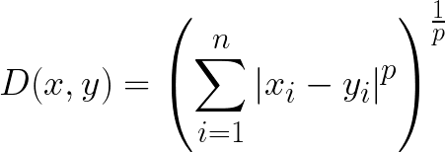
Minkowski is a generalisation of Euclidian and Manhattan for different numbers
- Weight function – If there should be different weights basis the distances. ‘Uniform’ has equal weight but ‘distance’ gives influence to neighbours who are closer
- How many neighbours selected – If K is high, the values are just averages but if K is small there are cases of sensitivity to outliers
- For KNN, The entire data set needs to be stored in system to calculate the distance and thus is not a good solver for big data sets or those with many features to consider

